Book Proposal
Questionnaire

Submitted by:
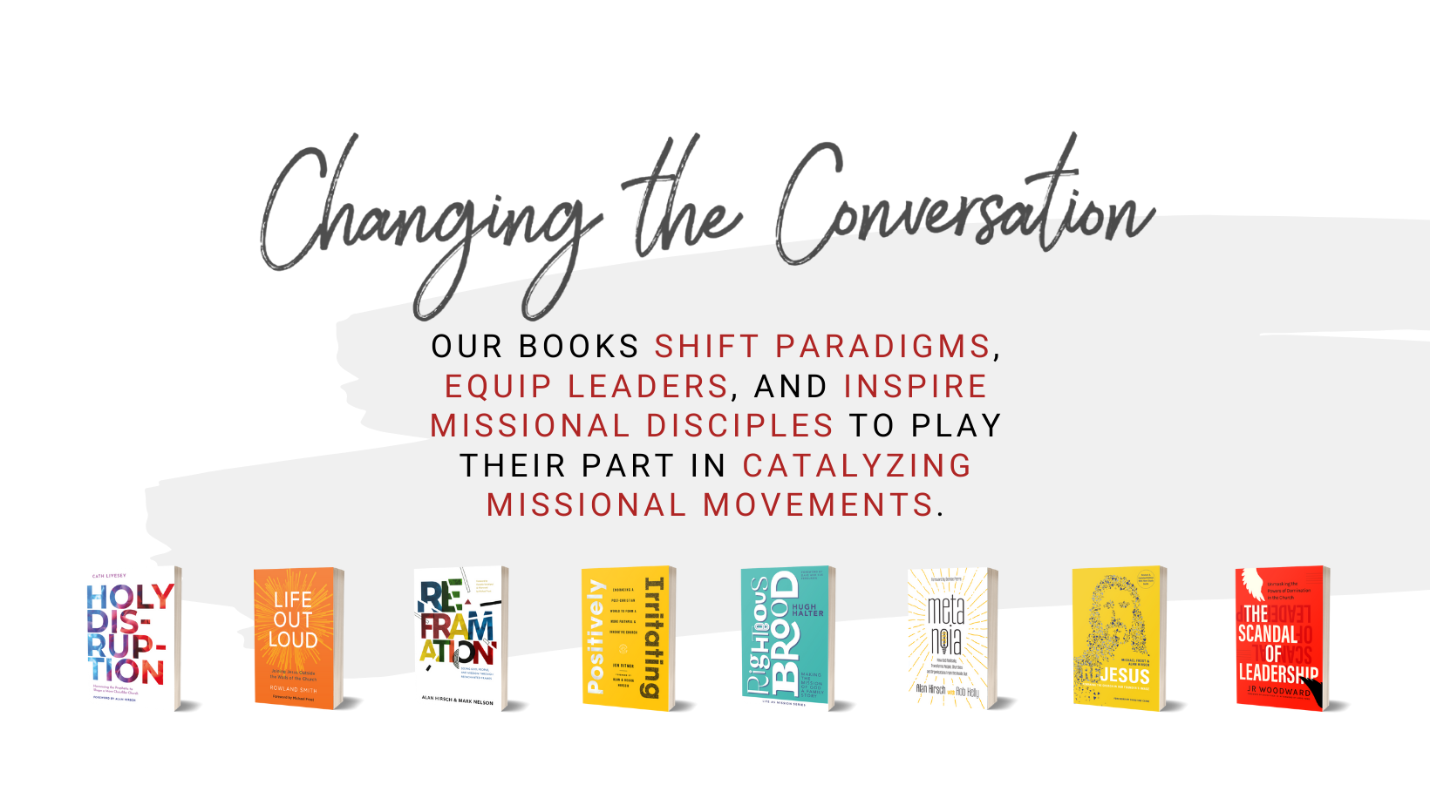

CONTENT

Working Title:

Working Subtitle:
(Does the title convey the thesis of the book to a reader in two seconds?)

One-Sentence Description:
(What is your “cocktail party” pitch, i.e., the one-sentence explanation your ideal reader would use to recommend your book to one of their friends.)

Half-page Description:

Tone:
(What tone will your book be written in [e.g., academic, popular, biographical, challenging, inviting, playful, serious])?

Brief chapter-by-chapter outline?
(Paste/write below. Or, if helpful, use the table below for each chapter to flesh out your ideas.)

Chapter Hook | - [Insert story or anecdote that sets up chapter]
Thesis of chapter | - [One sentence chapter thesis, same as in ToC]
Supporting content | - [Insert chapter content]  - [Insert chapter content]  - [Insert chapter content]  - [Insert chapter content]  - [Insert chapter content]  - [Insert chapter content]  - [Insert chapter content]
Stories | - [Insert stories that back up content]  - [Insert stories that back up content]
Key reader takeaways | - OPTIONAL: [Insert key takeaway for the reader]  - OPTIONAL: [Insert key takeaway for the reader]
Callback to Hook & segue to next chapter | - OPTIONAL: [Insert callback to opening story]  - OPTIONAL: [Insert segue to next chapter]

AUDIENCE
Who is your primary target audience?
(Who will read this book? Where can those readers be found? Describe the typical person in your primary audience. What are they like? Who are they? Where are they in life?)

Who is your secondary target audience?

THE MARKET

What are the big questions this book answers?
(What solution is your book solving? Why would a reader need to read this book? What is your reader’s current “pain point,” and how will your book help them?)

(What will have changed for your reader after reading this book? What impact do you hope it will have on the individual and on the church, organization, or culture?)

What is the unique about your book? What are you adding to the conversation?
(What does your book cover that no other book does?)

COMPETITIVE TITLES
(Give names and descriptions of other comparable books.)

MARKETING

Who can endorse the book and what could you do to encourage promotion?

OTHER DETAILS

Publication date:
(When do you hope to publish the book? )

Estimated word count:

Manuscript Delivery:
(When do you hope to complete your first draft?)

AUTHOR INFO
Have you got any previously published works?
(Please list them below)

Why are you qualified to write on your subject?

WRITING SAMPLE
(Please provide a short writing sample, between 750–1,000 words.. This can either be a chapter of your book or another piece of writing.)

